Name: _________________________________________ Date: _______________________ Class: ______________________
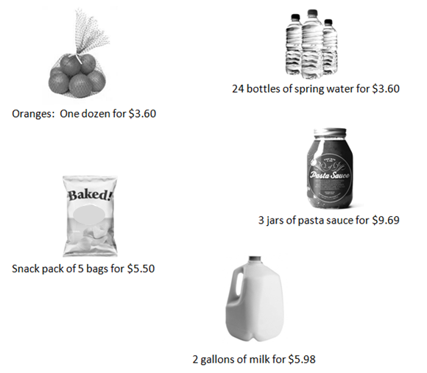
Sam’s Market Weekly Sale Flyer

Here are some items on sale at Sam’s Market. Find the unit rate (unit price) of each item, and fill in the chart below.
ITEM | Quantity Listed | Price Listed | Unit | Unit Price
Oranges | 12 | $3.60 | 1 orange

Name: _________________________________________ Date: _______________________ Class: ______________________
Justin’s Pizza

Justin needs to buy four pizzas for a party. He found the following three ads in his local newspaper:

Rosa’s Pizza | Pizza Mart | Collins Pizza
Each 12-inch pizza: $6.35  Buy 3 and get one free! | Each 12 inch pizza: $4.65 | Four-pack of  12-inch pizzas:  $19.60

Where would Justin get the best deal? Show your work.

Name: _________________________________________ Date: _______________________ Class: ______________________
Little Red Riding Hood’s Grocery Trip
After spending some time phoning and texting with Granny, Little Red Riding Hood decided it was time to visit her beloved grandmother, who lived in the Far, Far Away Woods. She thought it would be nice if she brought some groceries and fixed lunch for her elderly, yet hip, Granny. She remembered that her Granny loved tacos and brownies, so she decided that she would make them for her as a surprise! She quickly made her grocery list. Red decided she needed to buy:
- soft taco shells
- shredded cheese
- ground beef
- salsa
- lettuce
- brownies (for dessert, of course!)
Little Red Riding Hood scanned recent grocery store flyers and found that two different stores, the Very Hungry Wolf’s Food Store and the Strong, Brave Woodsman’s Food Mart, had all of the ingredients that she needed. Red didn’t have a lot of time to shop, so she decided to use the flyers to compare prices to help her decide which store had the best values. After comparing unit prices for each item, she totaled the unit prices and chose the store that would give her the best overall value.
Determine the unit price for each item at each grocery store. Put your answers in the place provided in the chart shown. You must show your work for each item. Once you have decided which grocery store will offer Red the best value for her money, explain why she should shop there. Give specific detail about how you decided whether she should shop at the Very Hungry Wolf’s Food Mart or the Strong, Brave Woodsman’s.

The Very Hungry Wolf’s Food Store |  |  |  | The Brave Woodsman’s Food Mart
Grocery Item | Price | Unit Price |  | Grocery Item | Price | Unit Price
Soft Taco Shells | 8 for $.96 |  |  | Soft Taco Shells | 12 for $1.68
Shredded Cheese | 7 oz. for $1.75 |  |  | Shredded Cheese | 1 lb. for $3.20
Ground Beef | 1 lb. for $2.50 |  |  | Ground Beef | 5 lbs. for $9.95
Salsa | 22 oz. for $3.30 |  |  | Salsa | 10 oz. for $1.98
Lettuce | 1 head for $.89 |  |  | Lettuce | 3 heads for $1.69
Brownies | 12 for $3.60 |  |  | Brownies | 4 for $1.00

________________________________________________________________________________________________________________________________________________________________________________________________________________________________________________________________________________________________________________________________________________________________________________________________________________________________________________________________________________________________________________________________________________________________________________________________________________________________________________________________________________________________________________________________________________________________________________________________________________________________________________________________________
Name: _________________________________________ Date: _______________________ Class: ______________________
Task 1: Student Directions
You have created an award-winning recipe for pizza. You must write a proposal to convince the cafeteria manager to use your recipe. The proposal will include the cost to feed 12, 60, and 240 students. To help persuade the manager, you must explain all of the mathematics used to create your budget.
- First, you will find the cost to make one pizza using your recipe.
- Second, you will determine the cost to make pizza for 12, 60, and 240 students.
- Last, you will write a proposal to the cafeteria manager.

Use the price sheet to determine the ingredients for your pizza.
You may use a calculator to perform the computations.
Use the template below to make a table showing the cost to make one pizza using your recipe.
The first line is partially completed as an example.
Important information:
Your pizza must include dough, sauce, cheese, and three other ingredients.
1 pound (lb) = 16 ounces (oz)
One 16-inch pizza serves 4 students.
Award Winning Pizza Recipe
(Recipe for One Pizza)
Ingredient | Amount Needed | Package Size | Price | Unit Cost  (cost per ounce) | Total Cost for 1 Pizza
Dough | 20 oz. | 60 oz. | $4.20

Price Sheet

Ingredient | Amount Needed | Package Size | Price
Dough | 20 oz. | 60 oz. | $4.20
Pizza Sauce | 5 oz. | 15 oz. | $1.20
Cheese (shredded) | 8 oz. | 16 oz. | $3.36
Pepperoni | 4 oz. | 12 oz. | $5.52
Meatballs | 8 oz. | 16 oz. | $3.84
Sausage | 8 oz. | 1 lb. | $4.16
Green Bell Peppers | 8 oz. | 1 lb. | $1.44
Onions | 8 oz. | 2 lbs. | $2.56
Mushrooms | 6 oz. | 24 oz. | $4.56
Tomatoes | 3 oz. | 12 oz. | $2.88
Black Olives | 6 oz. | 6 oz. | $1.86

Name: _________________________________________ Date: _______________________ Class: ______________________

Task 2

Determine the cost to make pizza for 12, 60, and 240 students. Remember, one 16-inch pizza serves 4 students. Create a table to show the following.
- the number of students
- how many pizzas are needed
- how much of each ingredient is needed
- the price of each ingredient
- the unit cost for each ingredient
- the total cost for each ingredient
- the total cost (based on unit rates) to feed 12, 60, and 240 students
You may a calculator to perform the computations.

Ingredient | Unit Cost for 1 pizza | Pizzas Needed  for 12 Students | Total Cost for 12 Students | Pizzas Needed for 60 Students | Total Cost for 60 Students | Pizzas Needed for 240 Students | Total Cost for 240 Students

Name: _________________________________________ Date: _______________________ Class: ______________________

Task 3: Proposal to the Cafeteria Manager

Write a proposal to convince the cafeteria manager to add your pizza to the school lunch menu. Your proposal should include the following.

- the tables you created for Tasks 1 and 2
- an explanation of the information provided in each table
- an explanation of the mathematics you used to create the information in each table
- a convincing argument for choosing your recipe.

____________________________________________________________________________________________________________________________________________________________________________________________________________________________________________________________________________________________________________________________________________________________________________________________________________________________________________________________________________________________________________________________________
____________________________________________________________________________________________________________________________________________________________________________________________________________________________________________________________________________________________________________________________________________________________________________________________________________________________________________________________________________________________________________________________________
____________________________________________________________________________________________________________________________________________________________________________________________________________________________________________________________________________________________________________________________________________________________________________________________________________________________________________________________________________________________________________________________________
____________________________________________________________________________________________________________________________________________________________________________________________________________________________________________________________________________________________________________________________________________________________________________________________________________________________________________________________________________________________________________________________________

