Name: __________________________________________ Class: _____________ Date: ________________________________
Learning Target 6: I can divide a fraction by a mixed or whole number.
Objective: I can divide fraction by a mixed or whole number.

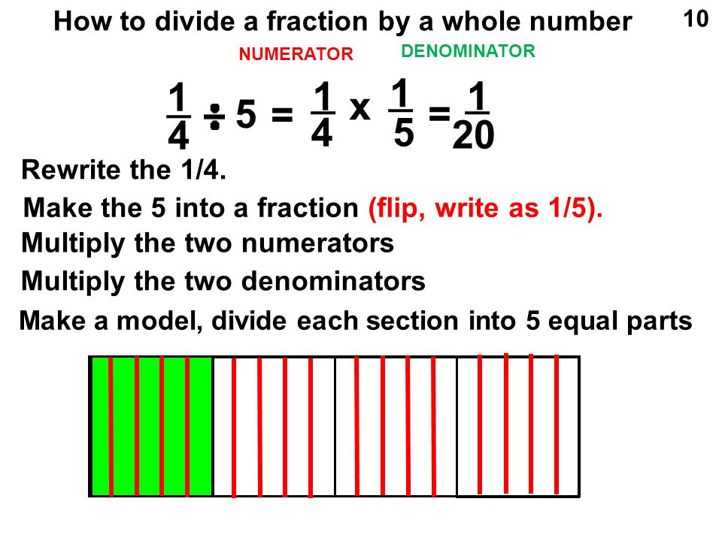
You use the same trick as you do when multiplying- you change everything to fractions and then go for it!

How to divide a fraction by a mixed number
$$\frac{3}{4} ÷ 2 \frac{1}{8} = \frac{3}{4}× \frac{8}{17}= \frac{24}{68}=\frac{6}{17}$$
Rewrite the ¾
Make 2 ¹/₈ into an improper fraction (flip, write as ⁸/₁₇).
Multiply the two numerators.
Multiply the two denominators.

1. $\frac{7}{8} ÷2\frac{3}{5}$ 2. $\frac{5}{16} ÷3$ 3. $\frac{2}{9} ÷1\frac{1}{3}$ 4. $\frac{3}{10} ÷3\frac{1}{2}$

1. Carli has 4 ½ walls left to paint in order for all the bedrooms in her house to have the same color paint. However, she has used almost all of her paint and only has ⁵/₆ of a gallon left. How much paint can she use on each wall in order to have enough to paint the remaining walls?

2. Justin invited his friends James and Austin over to play soccer. After running around his friends became thirsty, Justin went to the refrigerator and noticed he had ¾ of a gallon of juice left. How much juice can each friend get if he wants to divide it evenly?

3. Maria has ¾ lb. of trail mix. She needs to share it equally among 6 friends. How much will each friend be given?

4. Karla is baking a cake for the class party. She wants to bake 3 cakes but only has ²/₅ of a cup of frosting left. How much frosting can each cake get?

5. Mr. Kelly wants to reseed his 3 ¼ acre lawn. If he only has ⁷/₈ left of Scott’s Lawn Grass Seed, how much seed can he spread across each acre?

