Name: __________________________________________ Class: _____________ Date: ________________________________
Learning Target 5: I can divide a mixed or whole number by a fraction.
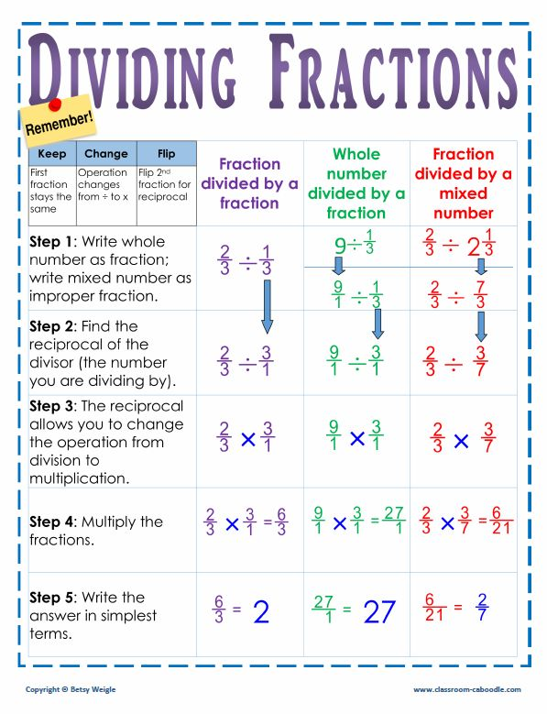
Objective: I can divide a mixed or whole number by a fraction.

Guided Practice
1. $2\frac{1}{4} ÷ \frac{3}{8}$ = 2. $6 ÷ \frac{1}{2}$ =

1. $3\frac{1}{2} ÷ \frac{2}{5}$ = 2. $4\frac{2}{3} ÷ \frac{1}{4}$ = 3. $8 ÷ \frac{5}{6}$ = 4. $7÷ \frac{2}{3}$ =

5. A baker is making cakes for a big party. She uses ¼ cup of oil for each cake. How many cakes can she make if she has a bottle of oil that has 6 cups in it?

6. The serving size for the granola that Ted likes to eat for breakfast is ¾ cup. How many servings are there in a box that holds 13 cups?

7. How many ½ cup servings are in a package of cheese that contains 5 ¼ cups altogether?

8. Mrs. Murphy’s class is making pillow cases. Each pillow case uses ¾ of a yard of fabric. How many pillow cases can they make out of 12 ½ yards of fabric?

