Name: __________________________________________ Class: _____________ Date: ________________________________
Multiplying Mixed Numbers and Fractions
Learning Target 3: I can multiply fractions and mixed numbers.
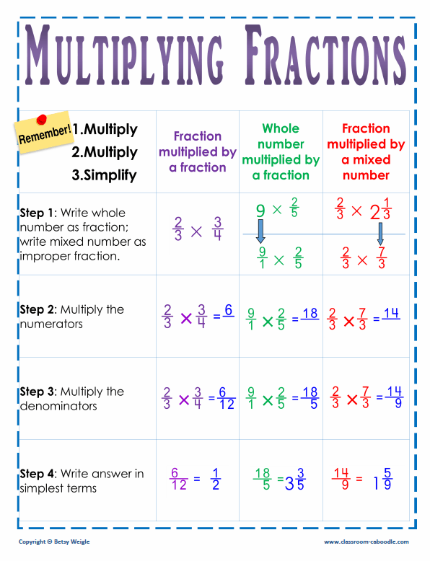
Objective: I can multiply two or more mixed numbers and fractions.

1. 3 ⁴/₅ x 5 2. 1 ³/₅ x 2 ¼ 3. 1 ½ x 3 ⁵/₆

4. 4 2/3 x 4 5. 3 1/7 x 1 ¼ 6. 1 1/3 x 2 1/6

7. A recipe says 2 ½ cups of flour to bake a batch of cookies. Sherry wants to bake 3 ¾ batches of cookies. How many cups of flour will Sherry need?

8.

