Name: __________________________________________ Class: _____________ Date: ________________________________

Multiplying a Fraction by a Fraction

**Learning Target 3**: I can multiply fractions and mixed numbers.

**Objective:** I can multiple two or more fractions.

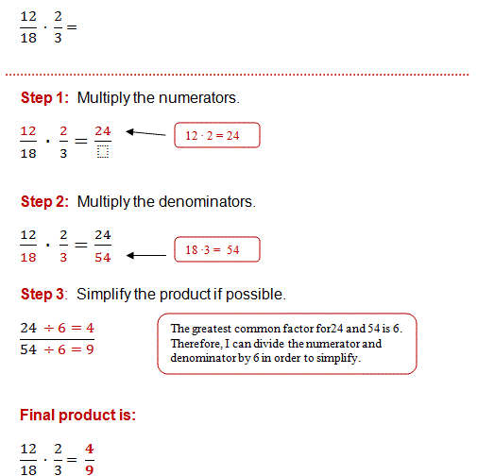

**X**

**X**

X

X

Guided Practice:

x

2. x

3. x

|  |  |  |
| --- | --- | --- |
| 1. | 2. | Image result for how to multiply a fraction by a fraction3. |
| 4. | 5. | 6. |

7. To amend the U.S constitution, ¾ of the states must approve the amendment. If 35 states approve an amendment, will the constitution be amended?

8. Emily has 6 eggs. She needs 2/3 of the eggs to make an omelet. How many eggs does she need?

9. Tom has ¾ of a pan of a lasagna. His friends at 2/3 of this amount of lasagna. What fraction of a whole pan of lasagna did his friends eat? Show your answer visually and with numbers. Lasagna

10. Barbara ordered 12 pizzas for a party. If each person eats 3/8 of a pizza, how many people can Barbara feed with 12 pizzas?