Name: ___________________________________________ Class: __________ Date: ___________________________
Learning Target 2: I can add and subtract mixed numbers.
Objective: I can convert between mixed numbers and improper fractions.
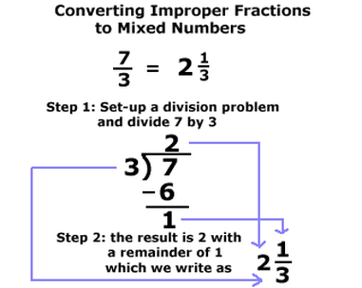
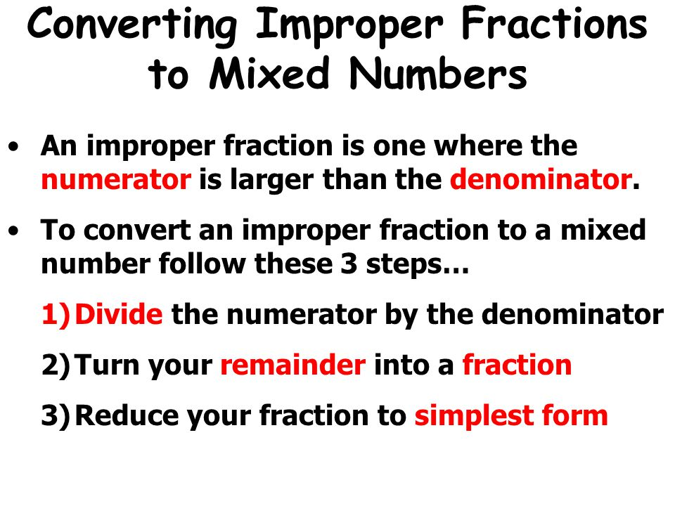

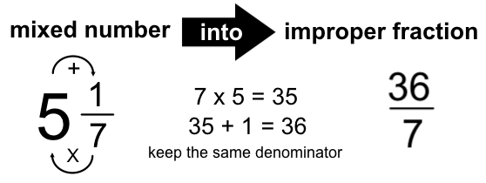
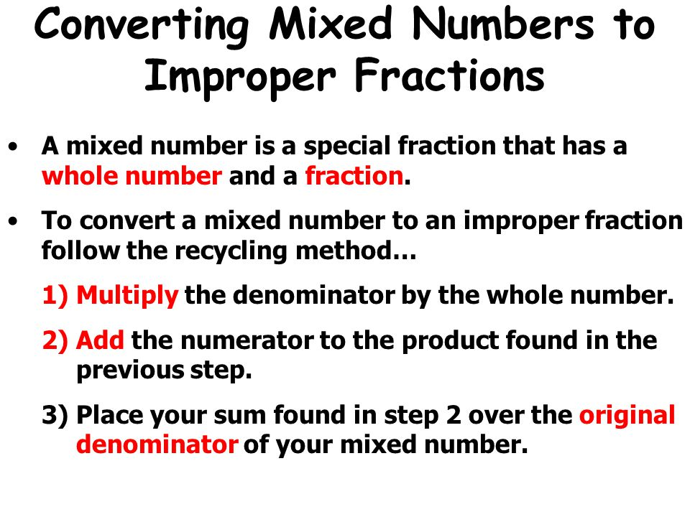

Directions: Write each improper fraction as a mixed number in simplest form.
1. $\frac{7}{3}$ 2.$\frac{41}{9}$ 3. $\frac{9}{5}$

4.$\frac{38}{7}$ 5. $\frac{14}{8}$ 6. $\frac{42}{6}$

Directions: Write each mixed number as an improper fraction.
1. $1\frac{3}{8}$ 2. $4\frac{2}{3}$ 3. $3\frac{1}{11}$

4. $5\frac{3}{5}$ 5. $2\frac{7}{12}$ 6. $8\frac{1}{4}$

Dwayne said that $\frac{9}{4}$ and $1\frac{1}{4}$ are equivalent. Is he right? Show your work and explain.

______________________________________________________________________________________________________________________________________________________________________________________________________________________________________________________

