Name: ___________________________________________ Class: __________ Date: ___________________________
Learning Target 1: I can add and subtract fractions.
Objective: I can subtract two or more fractions with unlike denominators.

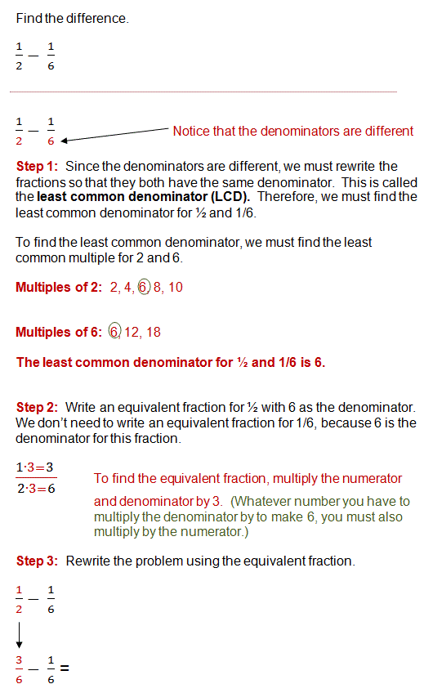
How do we subtract two or more fractions with unlike denominators?

Directions: Find the difference. Simplify, if necessary.
1. $\frac{4}{7}$ - $\frac{1}{3}$ 2.$\frac{14}{15}$ - $\frac{5}{9}$

3. $\frac{1}{2}$ - $\frac{3}{10}$ 4. $\frac{3}{4}$ - $\frac{3}{8}$

5. Linda had ²/₃ of a yard of fabric. She used ¼ yard of fabric she bought for a sewing project. How much fabric did she have left?

B. If Linda had started with one yard of fabric and used 5/8 of a yard, how much fabric would be left?

6. Melissa’s math class lasts ⁵/₆ of an hour. Only ³/₁₂ of an hour has gone by. What fraction of an hour remains of Melissa’s math class?

Hiker | Fraction of Trail Hiked
Andrea | ²/₅
John | ½
Caleb | ⁴/₅
7. The hiking trail around Pelham Bay Park in the Bronx is 5 miles long. Use the table for parts A and B.
A. What fraction more of the trail did John hike than Andrea?

B. What fraction more of the trail did Caleb hike than John?

