Name_______________________________ Class_____________ Date: ________________

Learning Target 1: I can add and subtract fractions.

Objective: I can simplify fractions using the greatest common factor.

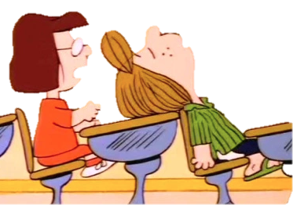

What’s the big emergency Darcy?!



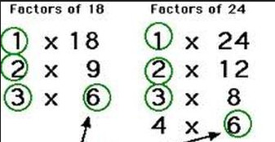

Everything Sir! The GCF is how we reduce fractions. First we find the GCF of the numerator and denominator, then we divide the numerator and denominator by their GCF. So the fraction 18/24 would be reduced to 3/4 after you divide 18 & 24 by their GCF, 6.

What does the GCF have to do with reducing fractions?

Groovy Darcy, I have to go to lunch detention now. Maybe I’ll practice reducing fractions with the GCF while I’m there. You know you really should take school more seriously Darcy.

GET UP SIR!

The GCF Sir, the GCF is the big emergency Sir. You’re not going to know how to find it and then you will never learn to properly reduce a fraction!





Please help Peppermint Patty with reducing the following fractions by using the GCF:

1) 4/8 2) 5/15

3) 4/16 4) 16/28

5) 21/24 6) 18/32