Name____________________________ Class_________ Date: _____________________

Learning Target: I can add and subtract fractions.

Objectives: I can identify common factors of whole numbers.

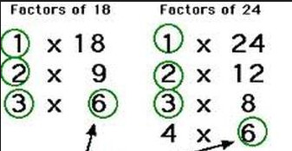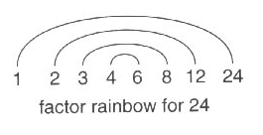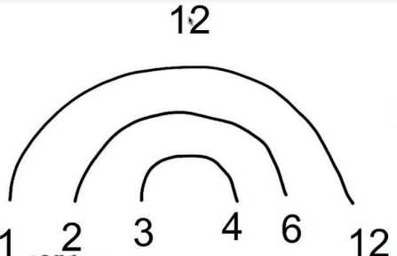

Now turn over and practice on your own

Actually girls both techniques are correct. You should use the one you are more comfortable with.

In this situation we can easily see that the common factors for 18 & 24 are 1,2,3,& 6

I personally hate factor rainbows. I prefer to find the factor pairs of each number then identify the common factors.

Now we can see that the common factors, the factors that BOTH NUMBERS SHARE, are 1,2,3,4,6, & 12.

The first way we can find common factors is by finding all of the factors of each number by making a factor rainbow. Then identify the common factors.



What he means to say is do whichever technique from the previous page you feel most comfortable with, and show your work.

^#,<>/”’^*)(

1) 5, 40 2) 30, 6

3) 10, 24 4) 6, 12

5) 20, 15 6) 20, 12

7) 40, 30 8) 17, 34