Learning Target 1: I can add and subtract fractions.
Objective: I can use multiples of whole numbers in order to create equivalent fractions.

Name_______________________ Class_________ Date: ______________
Hey Chuck, can you use multiples of whole numbers in order to create equivalent fractions?

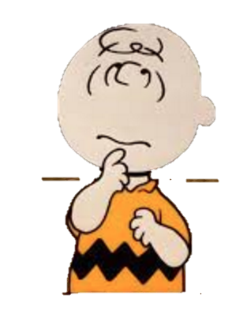
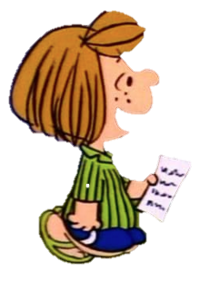
These are equivalent Fractions:
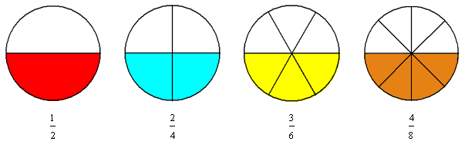
And so are these:
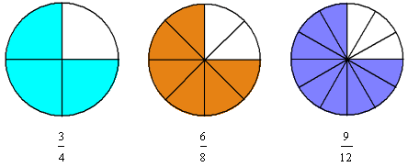
What would happen if we did not have shapes such as circles and rectangles to refer to?
You can multiply the numerator and the denominator of a fraction by any nonzero whole number, as long as you multiply both by the same whole number.
For Example:
Now turn the page over and try on your own!
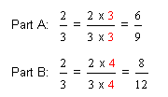

A proportion is an equation that states that two ratios or fractions are equal in value. When two fractions are proportionate the bottom and the top increase or decrease by the same number of times.

Write the missing numeral in the box.

