Name:___________________________________________________________ Date:___________________________ Class:____________________ A
Multiplying Fractions
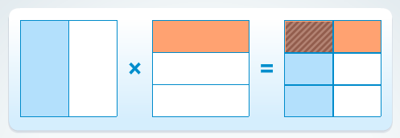

(1) ²/₃ x ¹/₄ = _____________ (2) ⁷/₈ x ⁵/₆ = _____________

(3) ¹/₃ x ³/₄ = _____________ (4) ¹/₅ x ³/₅ = _____________

(5) ³ /₈ x ⁵/₁₂=__________ (6) 3 ¹/₄ x 2 ³/₅ = __________

(7) ³/₈ x ¹/₄= __________ (8) ²/₃ x ¹/₃ = __________

Name:___________________________________________________________ Date:___________________________ Class:____________________ B

Multiplying Fractions

(1) 2 ²/₃x 1 ¹/₄ = _____________ (2) ⁷/₈ x ⁵/₆ = _____________

(3) 3 ¹/₃ x ³/₄ = _____________ (4) 1 ¹/₄ x ¹/₂ = _____________

(5) 3 ⁴/₅ x ³/₄ = _____________ (6) ¹/₅ x 2 ¹/₃ = _____________

(7) ²/₇ x ³/₈ = _____________ (8) 2 ⁴/₅ x ¹/₂ = _____________

