Name:___________________________________________________________________ Class:_______________
Learning Target: I can divide a decimal by a decimal.

YOU CANNOT DIVIDE WHEN THERE IS A DECIMAL OUTSIDE!

If you see a decimal outside in your division equation (the divisor) you must loop the decimal to the right until it is a whole number.
Ex) 0.8 -> loop one time to the right to make it 8
0.076 -> loop three times to the right to make it 76
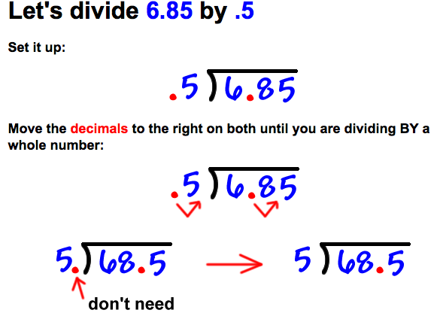
However many times you loop the decimal outside, you must also loop the decimal inside.

Steps:
(1) Loop the decimal point in the divisor until it is a whole number.
(2) Loop the decimal point in the dividend the same number of times.
(3) Is there a decimal in the dividend still? If yes, move it up!
OR Is there empty loops in the dividend? If yes, fill them in with zeros.
(4) Divide as usual.

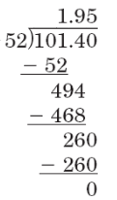
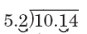
10.14 ÷ 5.2

Rewrite the equation using long division & Loop the decimal: | Solve the problem: | Rewrite the equation using long division & Loop the decimal: | Solve the problem: | Rewrite the equation using long division & Loop the decimal: | Solve the problem:

