Name: ______________________________________________ Date: _____________________ Class: ________________
Learning Target 9: I can convert between fractions, decimals and percents.

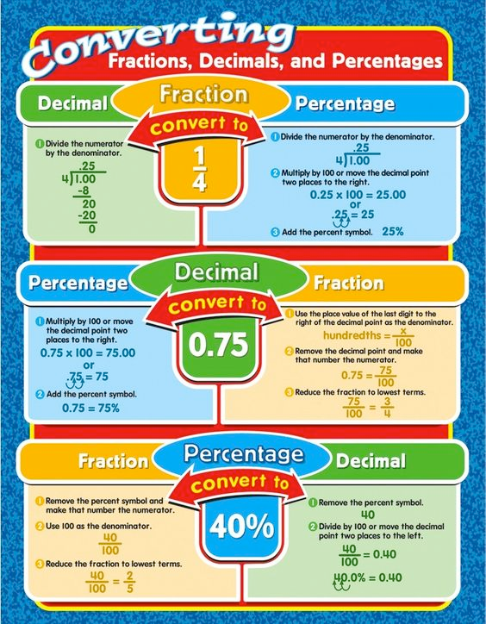
Objective: I can convert a decimal to a percent, and a percent to a decimal.

Let's Practice!
Write each decimal as a fraction and a percent.
0.36

Write each percent as a decimal and a fraction
44%

Write each fraction as a decimal and a percent
$$\frac{2}{5}$$

Complete the table below using your knowledge of fractions, decimal and percent conversions.

Problem | Fraction | Decimal | Percent
1. |  | 0.80
2. |  | 0.375 | 37.5%
3. | 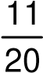 |  | 55%
4.
5. |  | 0.72
6. | 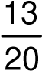
7. |  | 0.975
8. |  |  | 110%
9. | 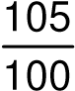
10. |  | 0.0046
11. |  |  | 112%
12. | 