Name: ________________________________________ Class: ______________________ Date: _______________________
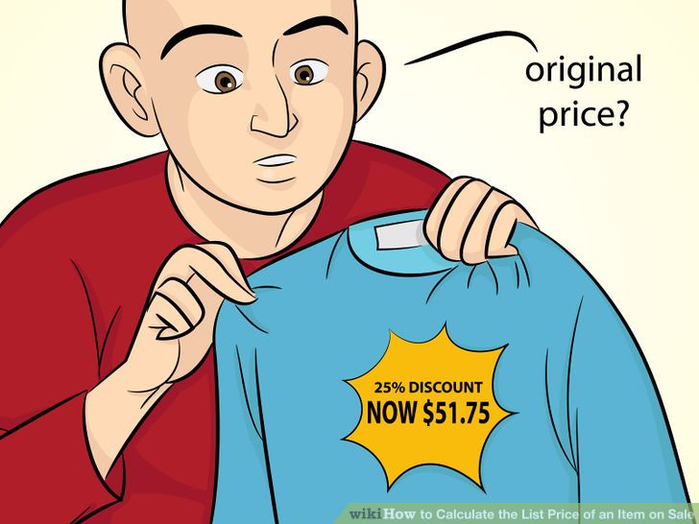
Learning Target: I can solve real world percent problems.
Objective: I can determine the original price.

How do we find the original price after a discount?
Method : Set up a proportion
Step 1: Subtract the discount (percent) from 100.
Step 2: Set up a proportion putting the sale price as the part.
Step 3: Cross multiply and divide by the number that has no partner.

Example:
Mr. Kelly bought a shirt that was 25% off. He paid $51.75. How much was the shirt before the discount?
Step 1: 100-25= 75
Step 2:$\frac{\$51.75}{X}= \frac{75}{100}$
Step 3: $51.75 x 100= 5,175
$5175 $÷75$ = $69

Mr. Kelly paid $69 for the shirt.

1. Griffin’s General Store is having a 30% off sale on fans. Robert paid $25 for a fan. What is the original price of the fan?

2. The Clothes Barn is having a 60% off sale on shorts. Ben paid $14 for a pair of shorts. What was the original price of the shorts?

3. Sunglass Shack is having a 50% off sale on sunglasses. Ann paid $22 for a pair of sunglasses. What was the original price?

4. Henley’s is having a 45% off sale on air conditioners. Fred pays $124 for an air conditioner. What was the original price?

5. Dream Vacations is having a 30% off sale on beach vacations. Albert pays $256 on a vacation. What was the original price?

6. Splash Swimming Pools is having a 62% off sale on pools. Ben paid $310 for a pool. What as the original price?

