Name: ______________________________________ Class: ______________ Date: ___________________________________
Learning Target 8: I can solve real world percent problems.
Objective: I can solve real world tax and tip problems.

What is sales tax and tip?
- Sales Tax is determined by finding a certain percentage of a purchase price. It is added to your total bill when you make a purchase.
- A tip is money given to someone to show appreciation for a service.

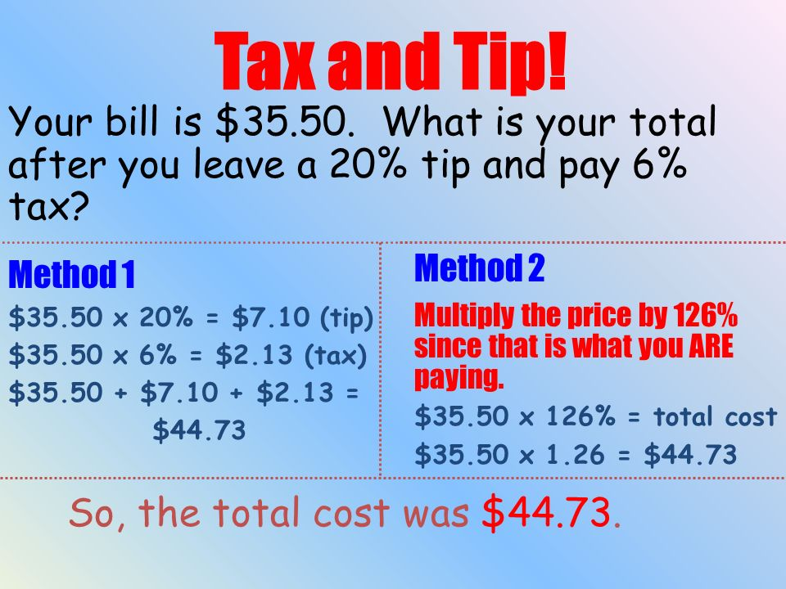
How do we find sales tax and tip?

Reminder!!!: To convert a percent to a decimal, move the decimal point two spaces to the left.

Guided Practice:
1. Your parents took your family out to dinner. Your parents wanted to give the waiter a 15% tip. If the total amount of the dinner was $42.00, what should be paid to the waiter as a tip?

- Toby buys a new MP3 player for a price of $45.50. What is the total amount his credit card is charged if the sales tax is 7%?
Method 1 Method 2

- John and his family went out to eat at their favorite restaurant. The bill for the food was $65.00, and they a left 20% tip for the server. What was the total cost of their meal (including tip)?
Method 1 Method 2

- If the sales tax for the city of Los Angeles is 9.75%, how much tax would you pay for an item that costs $200.00?

- Mrs. Smith paid $125 to have her hair colored and cut. If she tips her hairdresser 15% of her bill, how much was the tip?

- Bill and his friends went to Red Robin. Their order consisted of 2 hamburgers at $5.49 each, a chicken sandwich for $6.25, an order of ribs for $12.99, and 4 sodas at $1.75 each. They paid a 7% sales tax, and a 20% tip. How much money did lunch cost them?

