Name: ______________________________________ Class: __________________ Date: _______________________________
Learning Target 8: I can solve real world percent problems.
Objective: I can solve percent problems using a proportion.

How do we solve percent problems using a proportion?
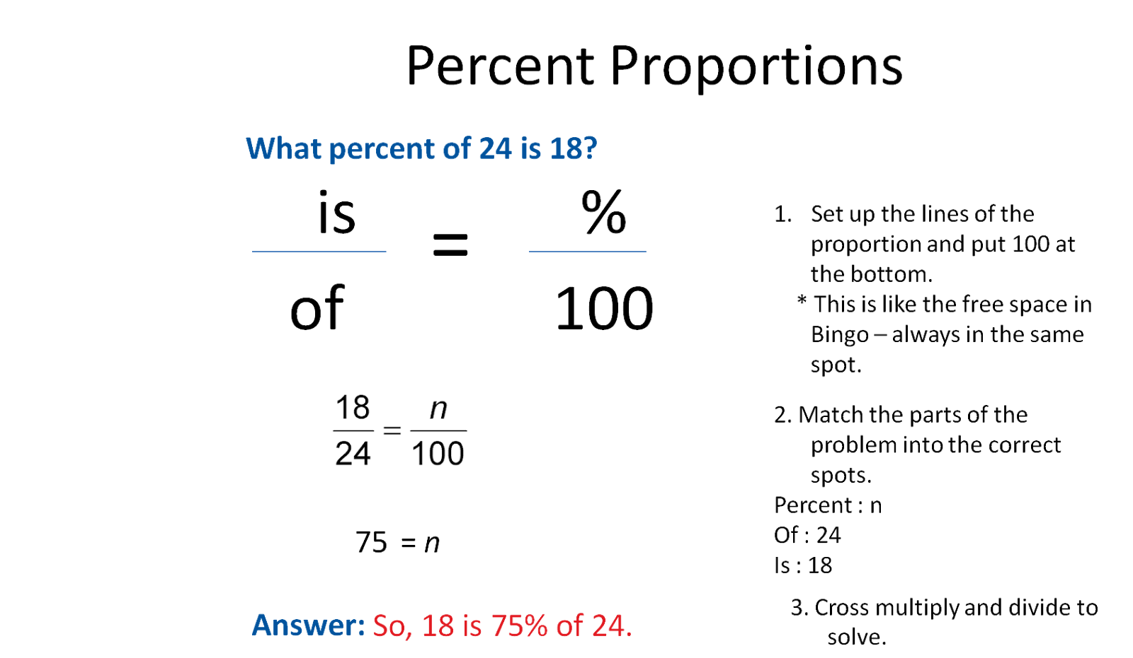
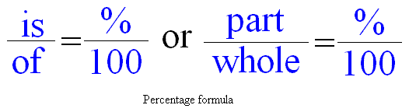
Percent statements always involve three numbers, given any two of these numbers, we can find the third using the proportion.

Name: ______________________________ Class: ____________ Date: ______________________
Directions: Use the proportion technique to solve the following problems.
1. What is 15% of 40?

2. 12 is 20% of what number?

3. 22 is what percent of 5?

4. 4 is what percent of the quotient of 15 and 3?

5. In a school, 25 % of the teachers teach basic math. If there are 50 basic math teachers, how many teachers are there in the school?

6. 24 students in a class took an algebra test. If 18 students passed the test, what percent do not pass?

