Name: _____________________________________ Class: _________________ Date: ________________________________
Learning Target 4: I can divide a whole number by a decimal.
Objective: I can divide a whole number by a decimal.
If you are dividing a whole number by a decimal, the whole number is the dividend: the number inside the division box OR the first number to appear in the number sentence and the decimal is the divisor: the number outside the division box OR the second number to appear in the number sentence.
YOU CANNOT DIVIDE WHEN THERE IS A DECIMAL OUTSIDE!
If you see a decimal outside in your division equation (the divisor) you must loop the decimal to the right until it is a whole number.
Ex) 0.4 -> loop one time to the right to make it 4
0.098 -> loop three times to the right to make it 98
However many times you loop the decimal outside, you must also loop the decimal inside.

BUT WAIT! I do not see a decimal inside?!

Remember, the decimal in a whole number, is always to the right of the ones place.
So, loop the decimal in the whole number the same number of times you did with the decimal in the divisor and fill in the empty loops with zeros.
Example:
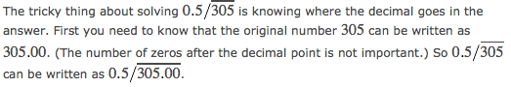
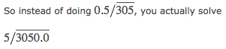
Steps:
(1) Loop the decimal point in the divisor until it is a whole number.
(2) Loop the decimal point in the dividend the same number of times.
(3) Fill in empty loops with zeros.
(4) Divide as usual.
Name:___________________________________________________________________ Class:_______________
1. Angie walks 2.75 miles home from school every day. She stops every .75 miles to rest and talk with her friends. How many stops will she make before she gets home?

2. Marc swims 5 laps in an Olympic sized pool in 0.25 of a hour. What is Marc’s speed?

3)14 ÷ 0.7 4) 100 ÷ 0.25 5) 4 ÷ 0.08

