Name: ___________________________________ Class: ____________________ Date: ________________________________
Learning Target 3: I can divide a decimal by a whole number.
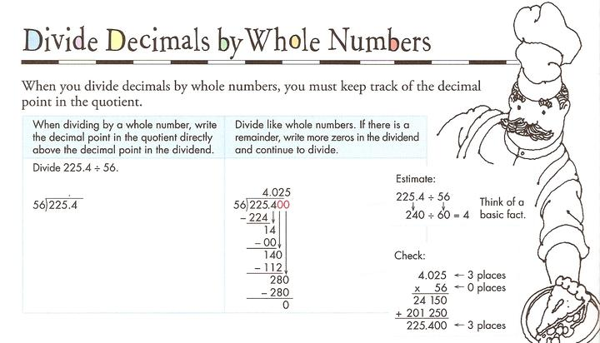
Objective: I can divide a decimal by a whole number

Guided Practice:
1) You and your two friends ran a lemonade stand. You made $63.12. How much money would each person get?

2) 2.35 $÷$5 3) 73.59 $÷$ 2

1) 38.7 ÷ 9 2) 37.6 ÷ 4 3) 43.4 ÷ 7

4) 280.63 ÷ 7 5) 44.64 ÷ 8 6) 12.25 ÷ 14

7) 3.6 ÷ 24 8) 64.26 ÷ 18 9) 34.64 ÷ 16

10) 0.918 ÷ 3 11) 61.299 ÷ 7 12) 30.045 ÷ 15

