Name: ___________________________________ Class: ____________________ Date: ________________________________
Learning Target 3: I can divide a decimal by a whole number.
Objective: I can divide a multi-digit whole numbers.
How to Divide!
Does McDonalds Sell Cheese Burgers?
U
B
T
R
A
C
T
R
I
N
G

D
O
W
N
H
E
C
K
U
L
T
I
P
L
Y

I
V
I
D
E

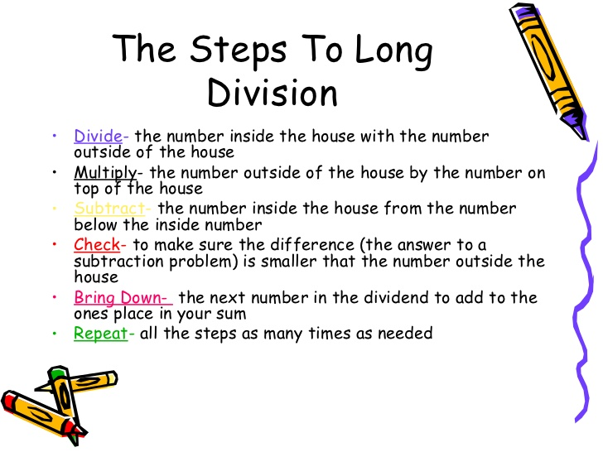

- 167 $÷$ 7 2) 67 $÷$ 2 3) 289 $÷$ 8

4) 482 $÷$ 11 5) 327 $÷$ 10 6) 6084 $÷$ 42

7) 3182 $÷$ 22 8) 3442 $÷$ 31 7) 729 $÷$ 14

8) 937 $÷$ 11 9) 656 $÷$ 10 10) 770 $÷$ 10

