Name: _______________________________________ Class: _______________ Date: ________________________________
Learning Target 2: I can multiply decimals.
Objective: I can multiply decimals.
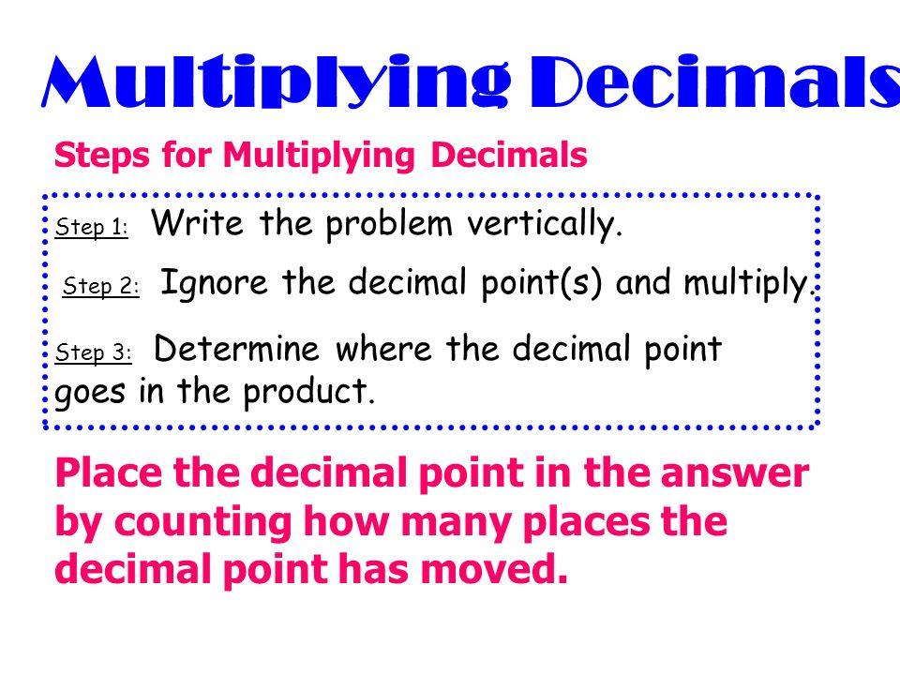
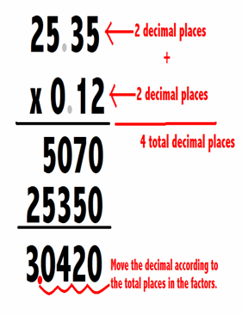

Guided Practice: Find each product

Name: _______________________________________ Class: _______________ Date: ________________________________
1. Johnny makes $4.75 per hour at his work. If he works 6 hours, how much money will he earn?

2. Tina’s cat weighs 2.6 kilograms. Her dog weighs 4 times as much as her cat. How much does her dog weigh in kilograms?

3) Katie can read 4.34 pages of a book in a minute. If she read for 3.6 minutes, how much would she have read?

4) Baby Isabel plays with blocks. Each block is 3.7 inches tall. She has a collection of 41 blocks. If she could stack all of the blocks up one on top of the other, how many inches tall would her tower of blocks be?

5)At the zoo the polar bears are fed 0.26 bucket of fish a day. The penguins are fed 0.9 that amount. How much of a bucket are the penguins fed?

6. Carrie likes to buy t-shirts at the local clothing store. They cost $9.95 each. One day, she bought 25 t-shirts. How much money did she spend?

7) Jim rides the bus to and from school each day. A one-way trip is 8.12 kilometers. How many kilometers does he travel in 3 days?

8) On Monday Cody picked up 0.92 of a kilogram of cans to recycle. On Tuesday he picked up 0.2 that amount. How much did Cody pick up on Tuesday?

9) An old road was 4.6 miles long. After a renovation it was 3.32 times as long. How long was the road after the renovation?

10) A new dish washing machine used 2.6 liters of water per full load to clean dishes. If Cody washed 0.4 of a load, how many liters of water would be used?

11) A bottle of soda had 3.5 of the daily recommended sugar. If you were to drink 0.4 of the bottle, how much of the daily recommend sugar would you have drank?

