Name: _______________________________________ Class: _______________ Date: ________________________________
Learning Target 2: I can multiply decimals Objective: I can multiply multi-digit whole numbers
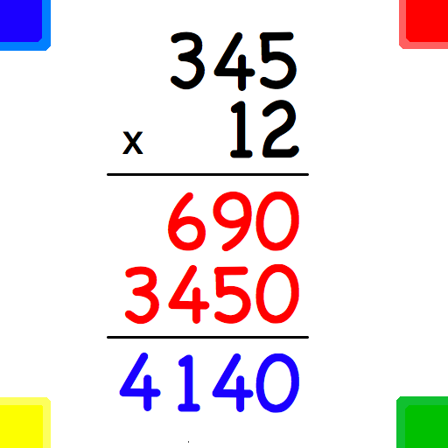
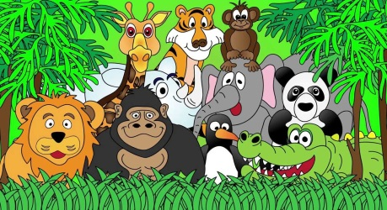
Many Zoos…… Many Animals!

Step 1: Multiply
Step 2: Zero (this allows us to move to the tens place)
+
Step 3: Multiply
Step 4: Add

Example: 